**KIDS ZONE**

***USER GUIDE***

|  |  |
| --- | --- |
| FACULTY | MISS QURATULAIN |
| BATCH | 2406E1 |
| GROUP | D |
| **ENROLLEMENT** | **NAME** |
| Student1579417 | ALIZA HABIB |
| Student1579426 | MAHNOOR |
| Student1583638 | MIDHAT HANIF |
| Student1581077 | HIFZA |

***INTRODUCTION***

*Welcome to Kids Zone, a delightful online space crafted to spark curiosity and learning in young children. Our platform is designed with toddlers and young learners in mind, combining fun, interactive with a safe, user-friendly environment. Here, children can explore foundational topics such as numbers, the alphabet, simple verses, and engaging poems. Each section offers colorful visuals, easy-to-follow instructions, and a playful learning experience aimed at nurturing creativity, imagination, and early learning skills. Whether it’s through educational games, stories, songs, or activities, Kids Zone provides a vibrant place for children to explore and grow.*

***HOME***

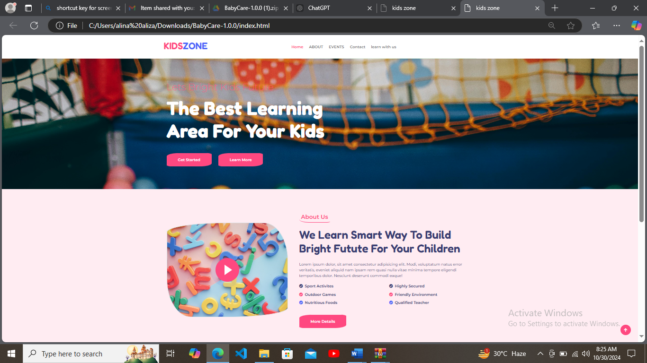

* *Interactive Platform: Kids Zone offers a range of fun, interactive activities designed specifically for toddlers and young learners.*
* *Educational Focus: The website covers key learning areas, such as numbers, alphabets, simple verses, and poems, supporting foundational skills.*
* *Colorful & Engaging: Each sect n is filled with bright visuals and engaging content to hold the attention of young children.*

*ABOUT US*

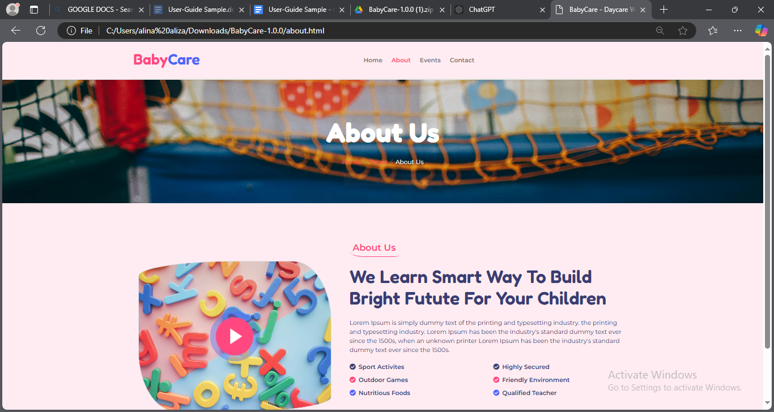

* Safe Learning Environment: Kids Zone is designed as a secure, ad-free space where young children can explore and learn with confidence.
* Engaging Content: We provide interactive and colorful activities that capture toddlers' attention and foster early learning in a playful manner.
* Educational Focus: Our sections cover fundamental topics like numbers, alphabets, basic Islamic verses, and poems, supporting essential developmental milestones.

**EVENTS**

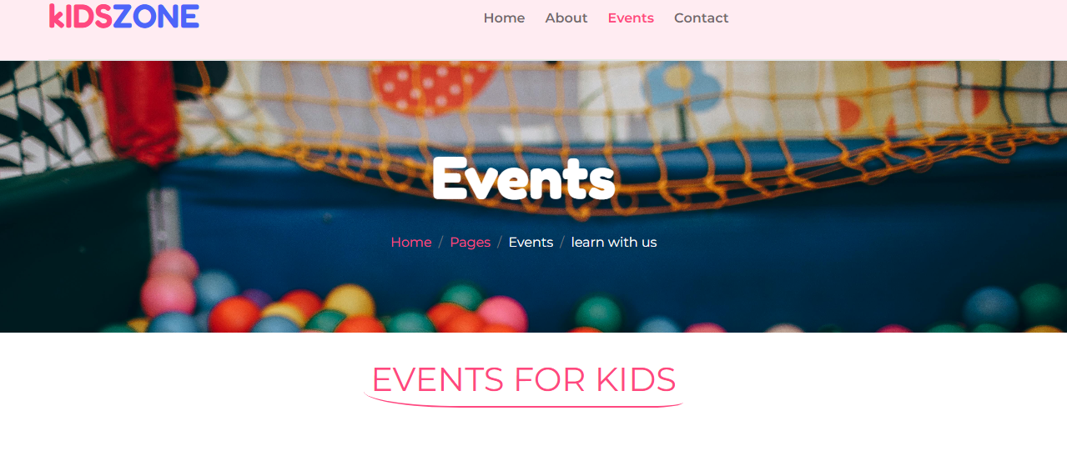

THERE ARE NUMEROUS EVENT IN OUR WEBSITE WHICH HELP IN INTELLUCTUAL LEVEL OF YOU KID.

* ABC PAGE IN HOVER. We have made our website letters in hover to provide your child more interaction with alphabets.
* 123 page to help him or her in counting. It will increase their counting strategy and help them in future.
* Islamic verses to help him or her in learning. As learning Arabic in young age will help them to increase their learning speed
* Different nursery rhymes to make them good speaker and in future help for learning.

***CONTACT***

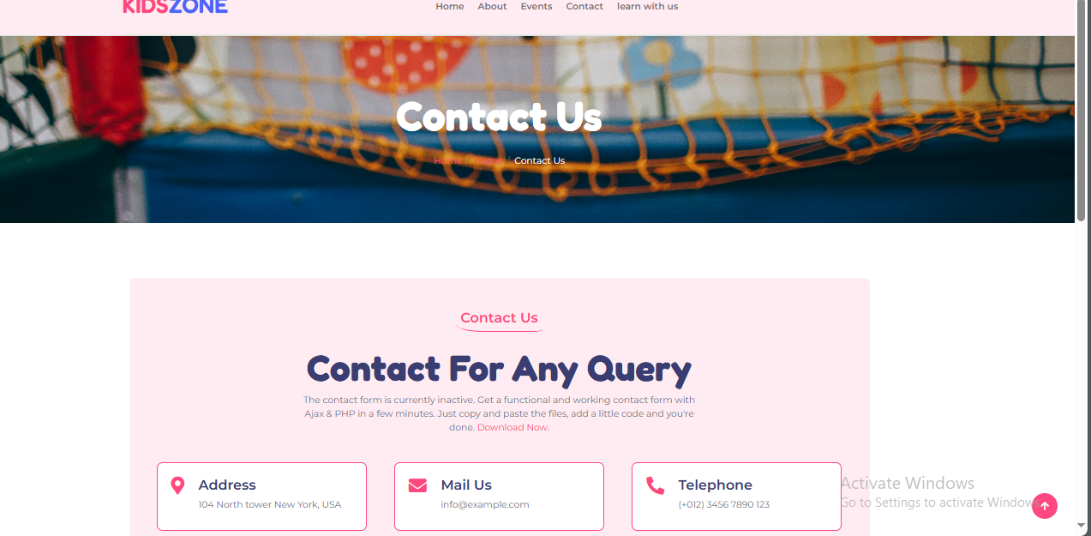

We have provided our users contact us page so for any query they could contact us. Providing contact us page in our website help the user to interact with the website maker. This page will provide more info to the users. Like for example this will help the user to give us feedback. The feedback can be of both types negative and positive.

***LEARN WITH US***

*This page is all about the learning. It provide info about learning. It is the most interactive page of our website as it has many user interactive material as our website is based on toddler website so we have used more colors and neutral colors. This provide more amazing content to user and develop more interest to them. As kids are our main motto so their likes and dislikes matter.*

***LEARN WITH US***